**Abstract-framed-arts-with-different-shapes**

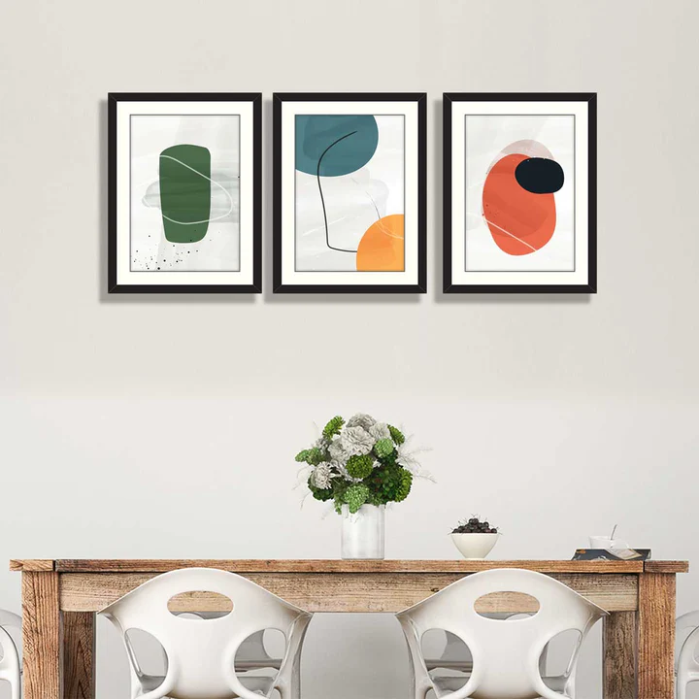Abstract Framed Arts with Different Shapes is a visually captivating collection that brings unique, modern flair to any room. Featuring a variety of shapes—such as circles, squares, triangles, and organic forms—these pieces explore the beauty of abstract design through bold colors, fluid lines, and unconventional patterns. The art often evokes emotion and invites interpretation, allowing each viewer to experience it in their own way. The frames, crafted from high-quality materials like wood or metal, complement the artwork and ensure it stands out as a statement piece in your home. Ideal for contemporary living rooms, bedrooms, or offices, this set adds a sophisticated, artistic touch to your décor, creating a dynamic atmosphere that sparks creativity and conversation.